# **M1Pro Creating DataFrame (Assignment Details)**

**Introduction**:

In this assignment students are to create a program that allows user to student names and scores, the program is to also allow defining the subject the grades are being entered for. The entered information is to be stored in a DataFrame

**Instructions**:

For this assignment, you will do the following

1.Create a Python code file named M1Pro_DataFrames_FirstLast.py   
(replace "FirstLast" with your own name)  
2. Add a title comment block to the top of the new Python file using the following form

# A brief description of the project  
# Date  
# CSC221 M1Pro – DataFrame  
# Your Name  
3. As explained in the introduction above, the program is for saving student scores for a specific number of tests.

4. First, the program is to ask user how many tests are the grades for. If 4 entered for instance, the program is to ask user to enter test names. **This would be used as indices for the grades that will be entered. (20 points )**

**5.** Next, the program is to ask user the number of students they would like to enter grades for. Then the program is to ask user to enter dictionary information as following: ( 50 points)

* Student Name
* List of grades (4 grades minimum)

**Note**: it’s important that the program allows entering name and grades for more than one student.

**Make sure that a dataFrame is created to store all of the information collected.**

6. Display the DataFrame content and verify that test names were assigned as labels for each row (**10 points**)

An example of the outcome is shown below

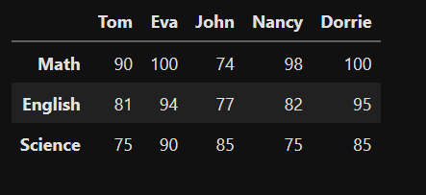

7. Calculate average for each Student and display results. Ex, what’s Tom’s average ? do this for all students in DataFrame (**10 points**)

**Submit** your finished code solution file(s) through the assignment link below

**Note**: Write program Pseudocode (detail algorithm) and add it as a comment block to the submitted program. (10 points)

**Grading criteria**:

Shown above